Review & Expand

OCQ26: What is the providence of God?
A: The almighty power of God, everywhere present, whereby He doth as it were by His hand uphold and govern heaven and earth, with all the creatures therein, so that those things which grow in the earth, as likewise rain and drought, fruitfulness and barrenness, meat and drink, health and sickness, riches and poverty; in a word, all things come not rashly or by chance, but by His fatherly counsel and will.

- The Almighty God who is everywhere acts!

- Preservation

- Concurrence

- Government

- God’s Decree and God’s Providence

God’s Decree
God hath decreed in himself, from all eternity, by the most wise and holy counsel of his own will, freely and unchangeably, all things, whatsoever comes to pass; yet so as thereby is God neither the author of sin nor hath fellowship with any therein; nor is violence offered to the will of the creature, nor yet is the liberty or contingency of second causes taken away, but rather established; in which appears his wisdom in disposing all things, and power and faithfulness in accomplishing his decree.
2LCF C3 Para 1

God’s Providence
God the good Creator of all things, in his infinite power and wisdom doth uphold, direct, dispose, and govern all creatures and things, from the greatest even to the least, by his most wise and holy providence, to the end for the which they were created, according unto his infallible foreknowledge, and the free and immutable counsel of his own will; to the praise of the glory of his wisdom, power, justice, infinite goodness, and mercy.
2LCF C5 Para 1

EPHESIANS 1:1

ROMANS 8:28

- Louis Berkhof ~ “That continued activity of God whereby He rules all things teleologically so as to secure the accomplishment of the divine purpose.”

Cf. 2LCF C5 Para 7 ~ “As the providence of God doth in general reach to all creatures, so after a more special manner it taketh care of his church, and disposeth of all things to the good thereof.”

EPHESIANS 1:20 ~ And He put all things under His feet, and gave Him to be head over all things to the church (NKJV)

NASB/ESV: to the church

NIV: for the church (Chinese Bible: 为教会)

NLT: for the benefit of the church

- . . . all things come not rashly or by chance, but by His fatherly counsel and will . . .

ISAIAH 49:14-16

I PETER 5:6-7

Two Slices Of Providence [II KINGS 8:1-15]

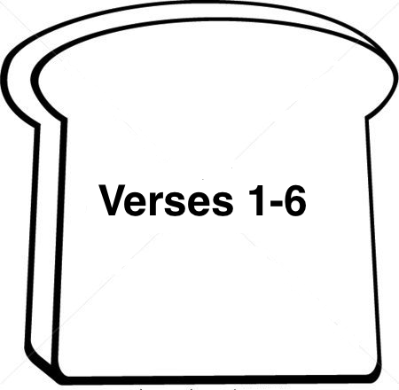
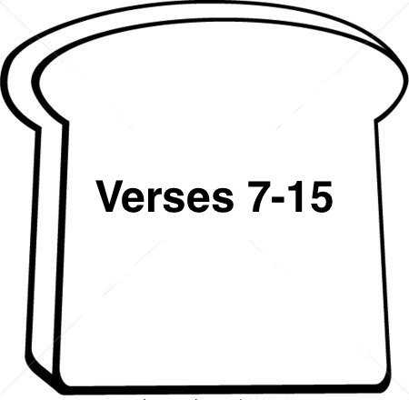

Whate'er my God ordains is right:
His holy will abideth;
I will be still whate'er He doth;
And follow where He guideth.
He is my God: though dark my road.
He holds me that I shall not fall.
And so to Him I leave it all,
He holds me that I shall not fall.

Whate'er my God ordains is right:
He never will deceive me.
He leads me by the proper path;
I know He will not leave
I take, content, what He hath sent.
His hand can turn my griefs away,
And patiently I wait His day,
His hand can turn my griefs away.

Whate'er my God ordains is right,
Though now this cup, I’m drinking,
May bitter seem to my faint heart,
I take it all, unshrinking
My God is true; each morn anew.
Sweet comfort yet shall fill my heart,
And pain and sorrow shall depart,
Sweet comfort yet shall fill my heart.

Whate’er my God ordains is right
Here shall my stand be taken
Though sorrow, need, or death be mine,
Yet I am not forsaken
My Father’s care
Is round me there
He holds me that I shall not fall
And so to Him I leave it all.

Words: Samuel Rodigast, 1676 (Was Gott tut, das ist wohlgetan);
translated from German to English by Catherine Winkworth, 1863, and others.
Rodigast wrote this hymn to cheer his friend Gastorius, precentor at Jena, who had become seriously ill.
Gastorius not only recovered, but went on to write the tune for Rodigast’s words.

